System and Software Architecture Description (SSAD)

FlowerSeeker

Team 05

Name | Roles
Eder Figueroa | Primary Role: Project Manager/ Implementer.  Secondary Role: Tester.
Sophia Wu | Primary Role: Tester/ Trainer  Secondary Role: Implementer
Doris Lam | Primary Role: IIV&Ver/ Quality Focal Point/ Implementer.  Secondary Role: Tester.
Hiram Garcia | Primary Role: IIV&Ver/ Quality Focal Point/ Implementer.  Secondary Role: Tester.

04/01/2013

Version History
Date | Author | Version | Changes made | Rationale
10/15/12 | YB, ZC | 1.0 | - Add Section 1 and Section 2.1.1 – 2.1.3 | - Initial Draft for FlowerSeeker SSAD document
10/22/12 | YB, ZC | 2.0 | - Add section 2.1, 2.1.4, 2.2 | - Add some needed new sections
10/25/12 | YB | 2.1 | - Add section 2.1.2 | - Complete section 2
11/04/12 | YB | 3.0 | - Revise 2.1.1, 2.1.2, 2.1.3 | - Correction for document
11/26/12 | YB | 4.0 | - Fix bugs, Add section 3, section 4 | - Correct some mistake in previous versions, and add two new sections
12/05/12 | YB,SW | 5.0 | - Revise section 3 | - Edit section 3 to Technology-Specific System Design and added some diagrams
12/10/12 | YB,SW | 6.0 | - Fix minor bugs | - Correct some mistakes in previous version.
12/15/12 | YB | 6.1 | - Fix minor bugs | - Correct some mistakes in previous version
2/4/13 | EF | 6.2 | - Updated diagrams | - Remove Struts FW references and replace with Spring FW  - Artifact diagram revised and updated for a more solid design  - After new incorporation of java frameworks and removal of hibernate and struts, frameworks sections was updated
2/20/13 | EF | 6.3 | - Updated diagrams | - Diagrams (artifacts model and sequence diagrams) updated after the ARB session by TAs and Instructors reviews
4/01/2013 | EF | 6.8 | - Updated use case Diagram | - After TA revision, the system behavior was revised. All general purpose ambiguous uses cases were fixed

Table of Contents
System and Software Architecture Description (SSAD) i
Version History ii
Table of Contents iii
Table of Tables iv
Table of Figures v
1. Introduction 1
1.1 Purpose of the SSAD 1
1.2 Status of the SSAD 1
2. System Analysis 2
2.1 System Analysis Overview 2
2.2 System Analysis Rationale 19
3. Technology-Specific System Design 21
3.1 Design Overview 21
3.2 Design Rationale 34
4. Architectural Styles, Patterns and Frameworks 35

Table of Tables
Table 1: Actors Summary 3
Table 2: Artifacts and Information Summary 4
Table 3: Hardware Component Description 23
Table 4: Software Component Description 23
Table 5: Florist Management Class Description 24
Table 6: Customer Management Class Description 25
Table 7: Product Management Class Description 26
Table 8: Review Management Class Description 27
Table 9: Coupon Management Class Description 28
Table 10: Payment Management Class Description 29
Table 11: Architectural Styles, Patterns, and Frameworks 35

-

Table of Figures
Figure 1: System Context Diagram 2
Figure 2: Artifacts and Information Diagram 4
Figure 3: Process Diagram 5
Figure 4: Hardware Component Class Diagram 21
Figure 5: Software Component Class Diagram 22
Figure 6: Deployment Diagram 22
Figure 7: Supporting Software Component Class Diagram 23
Figure 8: Florist Management Class Diagram 24
Figure 9: Customer Management Class Diagram 25
Figure 10: Product Management Class Diagram 26
Figure 11: Review Management Class Diagram 27
Figure 12: Coupon Management Class Diagram 28
Figure 13: Payment Management Class Diagram 29
Figure 14: Add Product Sequence Diagram 30
Figure 15: Florist Registration Sequence Diagram 30
Figure 16: List Added Product Sequence Diagram 31
Figure 17: Search by name Sequence Diagram 31
Figure 18: Search by price Sequence Diagram 32
Figure 20: Search by Occasion Sequence Diagram 32
Figure 21: Payment Sequence Diagram 33
Figure 22: Search by Location Sequence Diagram 33

Introduction

Purpose of the SSAD
The purpose of this SSAD is to record the results of the object-oriented analysis and design of our FlowerSeeker system. The programmers and developers of our team can use this SSAD as reference to the architecture of the system that we are developing. During the development of this system, our team will be faithful to the structure of the system described in SSAD.

Status of the SSAD
This version we included redesign on artifacts diagram and class diagrams and updated on sequence diagrams based on technology revision, TA, IIV&V, Instructor and client feedback.

System Analysis

System Analysis Overview
The purpose of our system Flower Seeker, which being developed now, is to provide an online market for flower customers and florist (flower seller). On Flower Seeker, customers can search for flowers based on style, price, florist rating, occasion and so on. On the other hand, it also provides a place for florist to easily upload the information of their flowers and sell them on web. Florist can purchase the membership design of flowers and make their own designs. In a word, Flower Seeker let the customers and florists get an opportunity to communicate with each other directly and build their business relationship based on that.

System Context
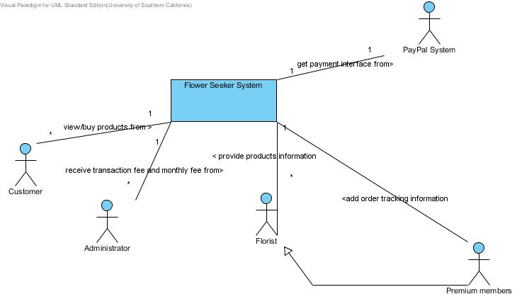
Figure 1: System Context Diagram

Table 1: Actors Summary
Actor | Description | Responsibilities
Florist | Users who sell flowers on this website | Provide detailed information of their products/flowers to Customer  Ships order in limited time period once order is placed  Generate coupons
Customer | Users who buy flowers from Florists on this website | Make Orders  Reviewed and Ranked the product he/she bought(Not Mandatory)
Administrator | An executive/managerial staff of this website. The administrator provides all the predefined stuffs including:  Predefined Occasions, licensed Design. | Provide Predefined Occasions  Provide licensed Design  Monitor System situation and block bad users
Premium member | Florist who pays monthly fee to FlowerSeeker website owner | Provide order tracking information
Paypal | Separate System being built by Paypal, with which the Flower Seeker Payment System must interact | Provide the interface for Flower Seeker System to give Flower Seeker System add to cart and payment system.

Artifacts & Information
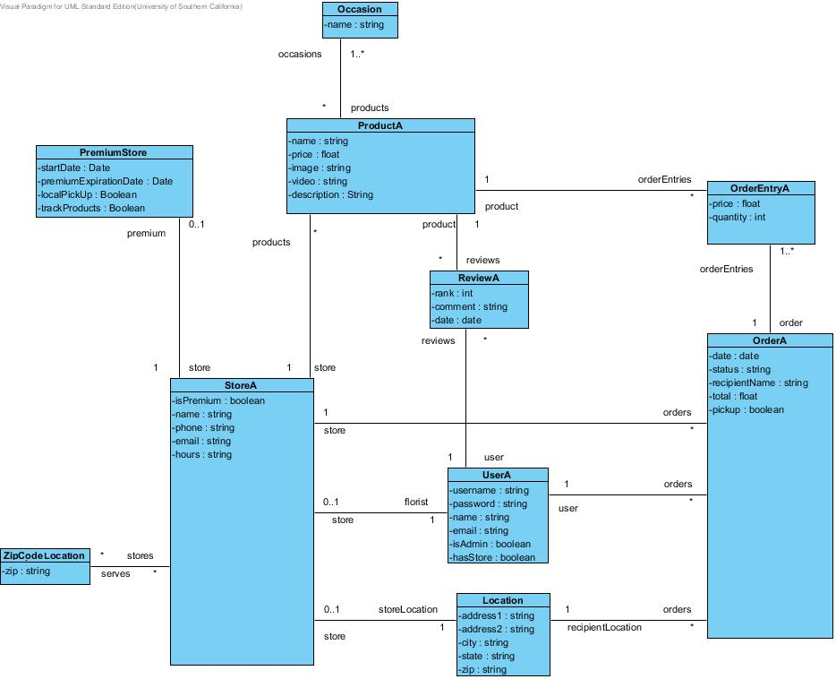

Figure 2: Artifacts and Information Diagram
Table 2: Artifacts and Information Summary
Artifacts | Information
Ocassion | This table contains all information regarding the special occasion a product can have
ProductA | This entity represents a flower product in flower seeker system
PremiunStore | This table contains all information regarding the premium account for a premium florist
OrderEntryA | This entity represents all information of a final order after a product is purchased
Review | This entity contains the information needed for the rank and review on each products
OrderA | This entity represents an order when one or many products are bought
Store | This entity represents each florist information
UserA | This entity represents each user information
zipCode | This entity contains all the destination zip codes where a store can deliver products
Location | This entity represents the physical location for each store registered

Behavior
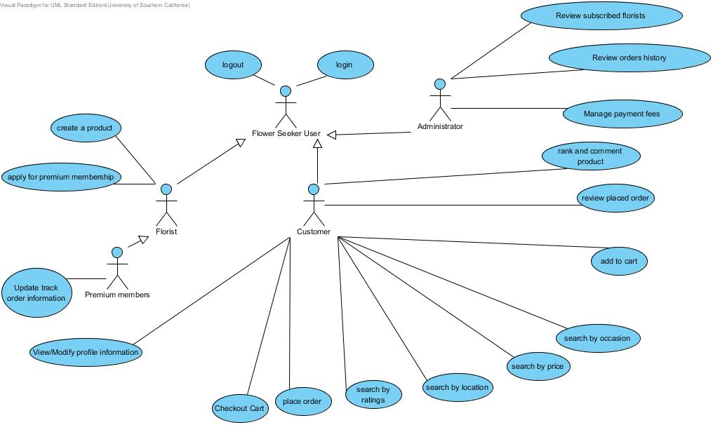
Figure 3: Process Diagram

Capability Login

Use Case 1
Process Description: Login
Identifier | UC-1: Login
Purpose | To determine whether the person logging into the system can be authenticated. If yes, then it need to figure out the role of the logged in person such as florist or buyer
Requirements | None
Development Risks | None
Pre-conditions | The user is currently on Login page
Post-conditions | User is authorized; the user will be given access to system operations appropriate to his/her role. Otherwise, the user is denied.

Typical Course of Action: login successful
Seq# | Actor’s Action | System’s Response
1 | enter user name and password and click login button
2 |  | Send the username and password to the flower seeker login checking system.  System validates entries and check for existing user.
3 |  | Redirect the user to the corresponding role’s main page
Exceptional Course of Action: login failed
Seq# | Actor’s Action | System’s Response
1-2 | Same as typical course actions 1-2
3 |  | System checks: entries for whether username exists and incorrect password username and password.
4 |  | Enables notification label “Wrong username, Wrong password” for the login page

Use Case 2
Process Description: logout
Identifier | UC-2: Log out
Purpose | Log out of current user and remove the sessions of current user’s.
Requirements | None
Development Risks | None
Pre-conditions | A user has logged in and currently on any page.
Post-conditions | The user logouts the system

Typical Course of Action: logout successful
Seq# | Actor’s Action | System’s Response
1 | click log out button
2 |  | Remove the session of current user, then redirect the page to flowerseeker home page

Capability Modify a product

Use Case 4
Process Description: modify product
Identifier | UC-4: create a product
Purpose | Allow florist to modify their existing products so that customers can see it and purchase them.
Requirements | WC_1407 WC_1444 WC_1453 WC_1458 WC_1459 WC_1460
Development Risks | None
Pre-conditions | Florists have logged in and on the product management page
Post-conditions | Florists have the updated description of the products uploaded.

Typical Course of Action: finish uploaded
Seq# | Actor’s Action | System’s Response
1 | Modifies any of the following product:  -Description  -Name  -Price  Selects:  -Product image  -Occasion
2 |  | Update the product description into the database  System redirects to Florist profile page
Alternate Course of Action: Incomplete product description
Seq# | Actor’s Action | System’s Response
1 | Leave any of the following product empty:  -Description  -Name  -Price  Selects:  -Product image  -Occasion
2 |  | System validates that all fields are non-empty.  Refresh florist product page and shows what missed field must be complete.

Capability Create a product

Use Case 3
Process Description: create a product
Identifier | UC-3: create a product
Purpose | Allow florist to create their products by themselves and shows it on the web so that customers can see it and purchase them.
Requirements | WC_1407 WC_1444 WC_1453 WC_1458 WC_1459 WC_1460
Development Risks | None
Pre-conditions | Florists have logged in and on the product management page
Post-conditions | Florists have the description of the products uploaded.

Typical Course of Action: finish uploaded
Seq# | Actor’s Action | System’s Response
1 | Fills product:  -Description  -Name  -Price  Selects:  -Product image  -Occasion
2 |  | Place the product description into the database and shows it on the page with the product when ever visited.  System redirects to Florist profile page
Alternate Course of Action: Incomplete product description
Seq# | Actor’s Action | System’s Response
1 | Fills product:  -Description  -Name  -Price  Selects:  -Product image  -Occasion
2 |  | System validates that all fields are non-empty.  Refresh florist product page and shows what missed field must be complete.

Capability Apply for premium membership

Use Case 5
Process Description: apply for premium membership
Identifier | UC-5: apply for premium membership
Purpose | Regular users can apply for premium membership in order to get premium features
Requirements | WC_1466
Development Risks | None
Pre-conditions | Florist has logged in is currently on the manage account page.
Post-conditions | Redirect to manage account page.

Typical Course of Action
Seq# | Actor’s Action | System’s Response
1 | click the “update to premium” button
2 |  | Displays update to premium page
3 | Fill required information and click “submit” button
4 |  | System saves the info in database and display Profile page

Capability View Customers’ Info

Use Case 6
Process Description: View Modify/Profile Information
Identifier | UC-6: View Customers’ Information
Purpose | Florist can view his customers’ contact information
Requirements | WC_1461
Development Risks | None
Pre-conditions | Florist has logged in and is currently on account management page
Post-conditions | Show all the customers’ information on screen.

Typical Course of Action
Seq# | Actor’s Action | System’s Response
1 | click “Modify profile information” button
2 |  | System shows all customers contact information on each corresponding field.
 | User modifies any information field, and press update button
 |  | System updates new information. Redirect to profile page

Typical Course of Action
Seq# | Actor’s Action | System’s Response
1 | click “Modify profile information” button
2 |  | System shows all customers contact information on each corresponding field.
User modifies any information field, and leaves empty information fields.
Press update button
 |  | System refresh page and activate label “All fields must be complete”

Capability Tracking Order

Use Case 7
Process Description: tracking order
Identifier | UC-7: Tracking order
Purpose | Premium member can allow their customers to track orders.
Requirements | WC_1466
Development Risks | None
Pre-conditions | Premium member has logged in and is currently on review order page.
Post-conditions | Order information is updated.

Typical Course of Action
Seq# | Actor’s Action | System’s Response
1 | click the “add phase” button
2 |  | System redirects to the review page
3 | Add the order information and click “submit” button
4 |  | System adds information in database and redirect to review order page.

Capability Order Management

Use Case 9
Process Description: add to cart
Identifier | UC-9: Customer: Add to cart
Purpose | Virtualizing a shopping cart to give buyers the ability to add products to shopping cart and allow buyers pay all the selected products in shopping cart together.
Requirements | WC_1446 WC_1408 WC_1400
Development Risks | None
Pre-conditions | Customer has logged in and is currently on any product information page
Post-conditions | Product is added to cart

Typical Course of Action: add to cart Successful
Seq# | Actor’s Action | System’s Response
1 | Click ‘Add to cart’ Button
 |  | System refresh cart page section reflecting product quantity and price changes.

Use Case 10
Process Description: Place Order
Identifier | UC-10: Place Order
Purpose | Finish Order
Requirements | WC_1446 WC_1408 WC_1400
Development Risks | None
Pre-conditions | Customer has logged in and is currently on the payment page
Post-conditions | Order is placed.

Typical Course of Action: Place Order Successful
Seq# | Actor’s Action | System’s Response
1 | Inputs shipping information
2 | Click ‘Place Order’ Button
3 |  | System verifies shipping information.  System generates communication credentials to PayPal.
4 |  | System redirects payment, and product information to PayPal.  System receives PayPal Answer
5 |  | System records approved order. Redirect to Order Successful Display Page

Alternate Course of Action: Wrong shipping information
Seq# | Actor’s Action | System’s Response
1 | Input shipping information
2 | Click ‘Place Order’ Button
3 |  | System verifies shipping information.
4 |  | Refresh page and activate “Review incorrect information”

Alternate Course of Action: Place Order Failure
Seq# | Actor’s Action | System’s Response
1 | Input shipping information
2 | Click ‘Place Order’ Button
3 |  | System verifies shipping information.  System generates communication credentials to PayPal.
4 |  | System redirects payment, and product information to PayPal.  System receives unsuccessful payment from PayPal
5 |  | User Refresh Page activating label PayPal unsuccessful payment label message

Capability Search

Use Case 11
Process Description: Search by ratings
Identifier | UC-11: Search by ratings
Purpose | Find the items that customers want by ratings
Requirements | WC_1446
Development Risks | None
Pre-conditions | Customer has logged in and is currently on the search page
Post-conditions | Display all the items related to the rating stars

Typical Course of Action: Search Successful
Seq# | Actor’s Action | System’s Response
1 | Click ‘ratings’ Button
2 |  | Display 1-5 stars on the screen
3 | Click corresponding star link
4 |  | Send stars to System Search module
5 |  | Search the items with rating at least the number of stars, return the results and display them.

Use Case 12
Process Description: Search by location
Identifier | UC-12: Search by location
Purpose | Find the items with specific location
Requirements | WC_1398
Development Risks | None
Pre-conditions | Customer has logged in and is currently on the search page
Post-conditions | Display all the items with the input location information
Typical Course of Action: Search Successful
Seq# | Actor’s Action | System’s Response
1 | Click ‘location’ Button
2 |  | Display location input table
3 | Fill in the location information.
4 |  | Check the completeness of input
5 |  | Send location information to System
6 |  | search the items with the same location, return the results and display them

Alternate Course of Action: Search Failure
Seq# | Actor’s Action | System’s Response
1 | Click ‘location’ Button
2 |  | Display location input table
3 | Fill in the location information.
4 |  | Check the completeness of input
5 |  | remind user which part he/she is missing in the input table

Use Case 13
Process Description: Search by price
Identifier | UC-13: Search by price
Purpose | Find the items that customers want by price
Requirements | WC_1445
Development Risks | None
Pre-conditions | Customer has logged in and is currently on the search page
Post-conditions | Display all the items related to the price

Typical Course of Action: Search Successful
Seq# | Actor’s Action | System’s Response
1 | Click ‘price’ Button
2 |  | Display several options on the screen
3 | Click corresponding price link
4 |  | Send price to System Search module
5 |  | Search the items with price at most this price, return results and show on screen

Use Case 14
Process Description: Search by occasion
Identifier | UC-14: Search by occasion
Purpose | Find the items that customers want by occasion
Requirements | WC_1445
Development Risks | None
Pre-conditions | Customer has logged in and is currently on the search page
Post-conditions | Display all the items related to the occasion

Typical Course of Action: Search Successful
Seq# | Actor’s Action | System’s Response
1 | Click ‘occasion’ Button
2 |  | Display several options on the screen
3 | Click corresponding option link
4 |  | Send occasion to System Search module
5 |  | Search the items with this occasion, return results and show on screen

Capability order management

Use Case 15
Process Description: review placed order
Identifier | UC-15: review placed order
Purpose | Show the customer a list of his/her orders placed before.
Requirements | WC_1406
Development Risks | None
Pre-conditions | Customer has logged in and is currently on the profile page
Post-conditions | The orders placed by this customer is showed on current web page

Typical Course of Action: show order history successful
Seq# | Actor’s Action | System’s Response
1 | click the show order history button
2 |  | System retrieves the corresponding information from the database. Then shows it to the webpage of user
Alternate Course of Action: show order history failure
Seq# | Actor’s Action | System’s Response
1 | click the show history button
2 |  | System have problem to get information from database or shows it on web. Then show a dialog box to ask user try it again. redirected to previous page

Use Case 18
Process Description: review all the subscribed florists
Identifier | UC-18: review order history
Purpose | Show who are subscribing premium membership
Requirements | WC_1467
Development Risks | None
Pre-conditions | Admin has logged in
Post-conditions | Show all the order on the page

Typical Course of Action: Order history
Seq# | Actor’s Action | System’s Response
1 | Click ‘See order histories’ link
2 |  | System lists all orders on groups of max 50 items peer screen.

Capability Rank and Review

Use Case 16
Process Description: Rank and Review on florist
Identifier | UC-16: Review Scoring on florist
Purpose | Allow Customers to rank and review on florists
Requirements | WC_1451 WC_1452
Development Risks | None
Pre-conditions | Customer has logged in and is currently on any page of product that he has bought before.
Post-conditions | Review and rank star show on this product page

Typical Course of Action: Rank and Review on florist successful
Seq# | Actor’s Action | System’s Response
1 | write comments in the comment textbook and click 1-5 star, click the ‘submit’ button
2 |  | Check the completeness, calculate the overall rank of this product
3 |  | Show rank and review on this product’s page

Alternate Course of Action: rank and review failure
Seq# | Actor’s Action | System’s Response
1 | write comments in the comment textbook and click 1-5 star, click the ‘submit’ button
2 |  | Check the completeness; calculate the overall rank of this product again. redirected to previous page
3 |  | Stay on the previous page and show what information are missing in the required fields

Capability Upgrade

Use Case 17
Process Description: Upgrade regular user to premium member
Identifier | UC-17: Upgrade regular user to premium member
Purpose | Upgrade regular user to premium member
Requirements | WC_1466
Development Risks | None
Pre-conditions | Admin has logged in and is currently on the grand premium member page
Post-conditions | Some regular members are changed to premium members

Typical Course of Action: Upgrade successful
Seq# | Actor’s Action | System’s Response
1 | Click ‘show requests’ button
2 |  | System shows all the regular users that applied for premium membership but did not get grant.
3 | Select regular users who applied for the premium membership and click “grant” button
4 |  | System change those regular users to premium members

Capability Order Management

Capability View premium members’ Info

Use Case 19
Process Description: review all the subscribed florists
Identifier | UC-18: : review all the subscribed florists
Purpose | Show who are subscribing premium membership
Requirements | WC_1467
Development Risks | None
Pre-conditions | Admin has logged in
Post-conditions | Show all the subscribed florists on the page

Typical Course of Action: Rank and Review on florist successful
Seq# | Actor’s Action | System’s Response
1 | Click ‘show subscribed members’ button
2 |  | System shows all the premium members on the screen.

Modes of Operation
FlowerSeeker system will operate in only one mode, so there is no additional information concerning modes of operations provided.

System Analysis Rationale
The following is the Analysis Rationale section for the FlowerSeeker System project:
FlowerSeeker Users - these users include florists, customers, and administrator. These users require authentication in order to access the system with various permissions and functionalities based on the type of user.
There is 1 external system actor that interface with the Flower Seeker System. It is:
Google wallet system – it provides payment system but requires a monthly fee which we can accept

Technology-Specific System Design

Design Overview

System Structure
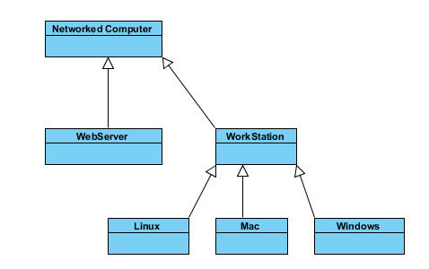
Figure 4: Hardware Component Class Diagram

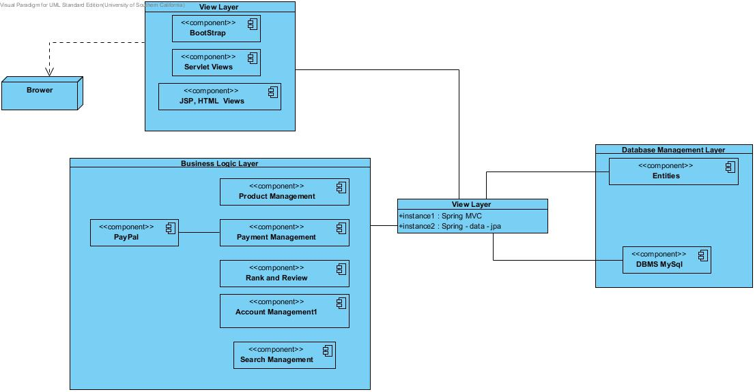
Figure 5: Software Component Class Diagram
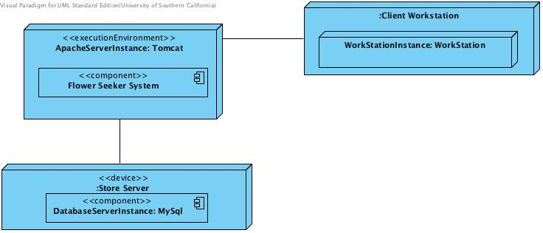
Figure 6: Deployment Diagram

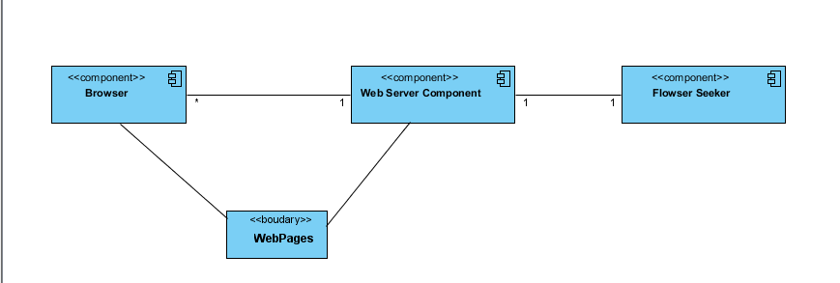

Figure 7: Supporting Software Component Class Diagram
Table 3: Hardware Component Description
Hardware Component | Description
Web server | FlowerSeeker System deployed on it
Work station | Users’ computer in which they use browser to visit this system
Linux | Users’ computer with Linux OS
Windows | Users’ computer with Windows OS
Mac | Users’ computer with Mac OS
Networked Computer | Networked Computer

Table 4: Software Component Description
Software Component | Description
Presentation Layer | Serve as GUI of this system, mapping users’ actions to business logic layer’s actions to process, show the data received from the business logic layer.
Business logic layer | Manage entire business logic of the system
Data Management Layer | It contains all the tables in the database. Every Entity Class corresponds to one Table in database. DAO contains all the operating class for those entities.
Framework Layer | Provides instances to main object to all business and data management layers within the system

Design Classes

Account Management Classes
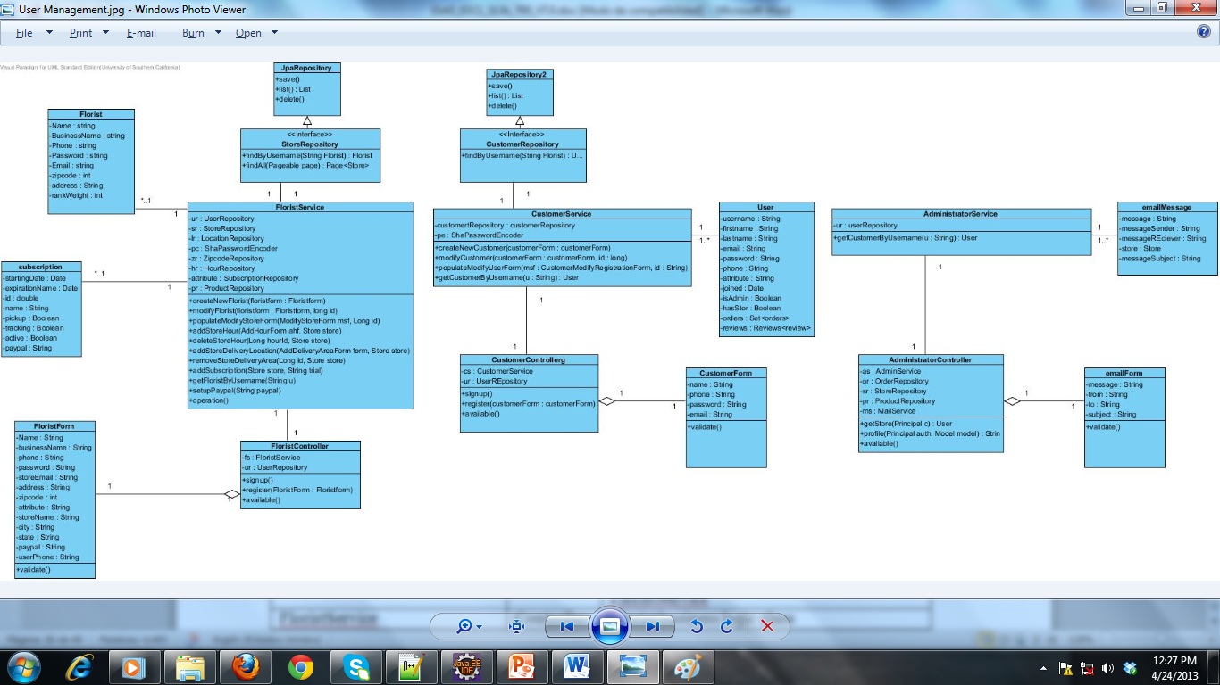
Figure 8: Florist Management Class Diagram
Table 5: Florist Management Class Description
Class | Type | Description
Florist | Entity | It contains florist data model
FloristForm | Controller | Contains the information in a form format used to render GUI in JSP
FloristController | Controller | Control events between GUI and FloristService
FloristService | Controller | Florist business logic class
FloristRepository | Controller | Interface
JpaRepository | Controller | Allows to use java JPA for serialization of Florist model
PremiumUser | Entity | Contains Florist premium entity model

Figure 9: Customer Management Class Diagram
Table 6: Customer Management Class Description
Class | Type | Description
Customer | Entity | It contains Customer data model
Customer Form | Controller | Contains the information in a form format used to render GUI in JSP
Customer Controller | Controller | Control events between GUI and Customer Service
CustomerService | Controller | Customer business logic class
Customer Repository | Controller | Interface
JpaRepository | Controller | Allows to use java JPA for serialization of Customer model

Figure 10: Administrator Management Class Diagram
Table 7: Administrator Management Class Description
Class | Type | Description
emailMessage | Entity | It contains Administrators email data model
emailForm | Controller | Contains the information in a form format used to render GUI in JSP
AdministratorController | Controller | Control events between GUI and AdministratorService
administratorService | Controller | Administrator business logic classes

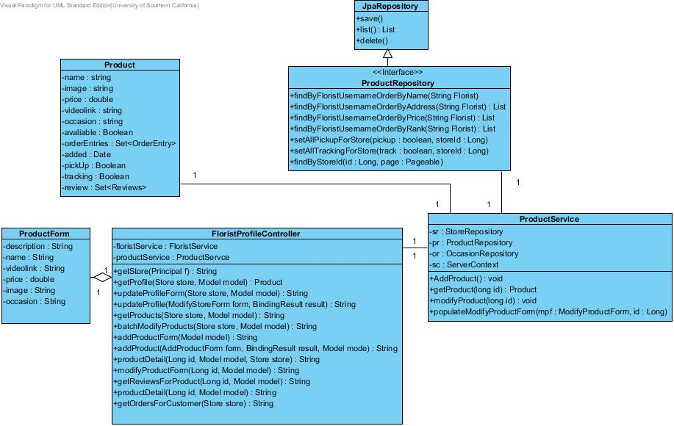
Figure 11: Product Management Class Diagram
Table 8: Product Management Class Description
Class | Type | Description
Product | Entity | It contains Product data model
Product Form | Controller | Contains the information in a form format used to render GUI in JSP
Product Controller | Controller | Control events between GUI and Product Service
Product Service | Controller | Product business logic class
Product Repository | Controller | Interface
JpaRepository | Controller | Allows to use java JPA for serialization of Product model

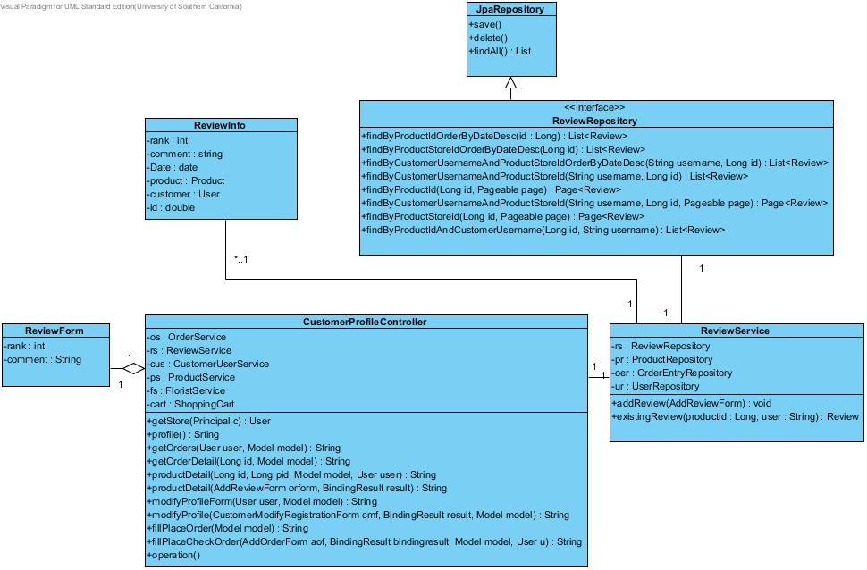

Figure 12: Review Management Class Diagram
Table 9: Review Management Class Description
Class | Type | Description
Review | Entity | It contains Review data model
Review Form | Controller | Contains the information in a form format used to render GUI in JSP
ReviewController | Controller | Control events between GUI and Review Services
ReviewService | Controller | Review business logic class
ReviewRepository | Controller | Interface
JpaRepository | Controller | Allows to use java JPA for serialization of Product model

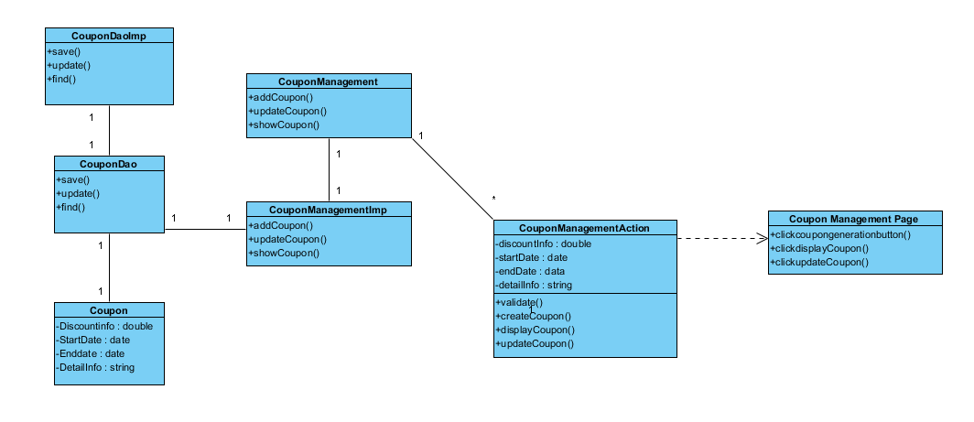
Figure 13: Coupon Management Class Diagram
Table 10: Coupon Management Class Description
Class | Type | Description
Coupon | Entity | It contains Coupon’s data
Coupon Dao | Controller | Interface
Coupon DaoImp | Controller | Implements Product Dao
CouponManagementImp | Controller | Implements ProductManagement
CouponManagementAction | Controller | Validate inputs and call on corresponding services.
CouponManagement | Controller | Interface
CouponManagementPage | Boundary | Web GUI

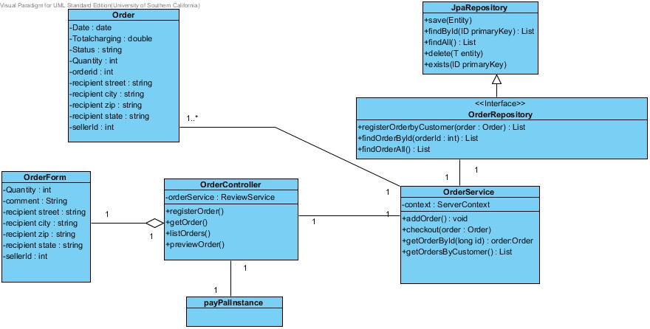
Figure 14: Payment Management Class Diagram
Table 11: Payment Management Class Description
Class | Type | Description
Order | Entity | It contains Order data model
Order Form | Controller | Contains the information in a form format used to render GUI in JSP
Order Controller | Controller | Control events between GUI and Order Services
Order Service | Controller | Order business logic class
Order Repository | Controller | Interface
JpaRepository | Controller | Allows to use java JPA for serialization of Order model
GoogleWalletInstance | Controller | NDI that manages checkout process

Process Realization
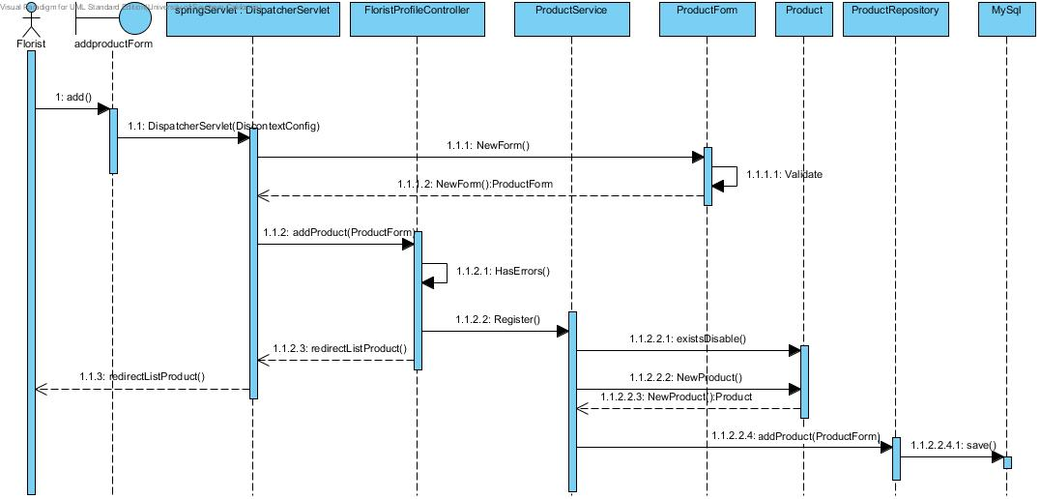
Figure 15: Add Product Sequence Diagram

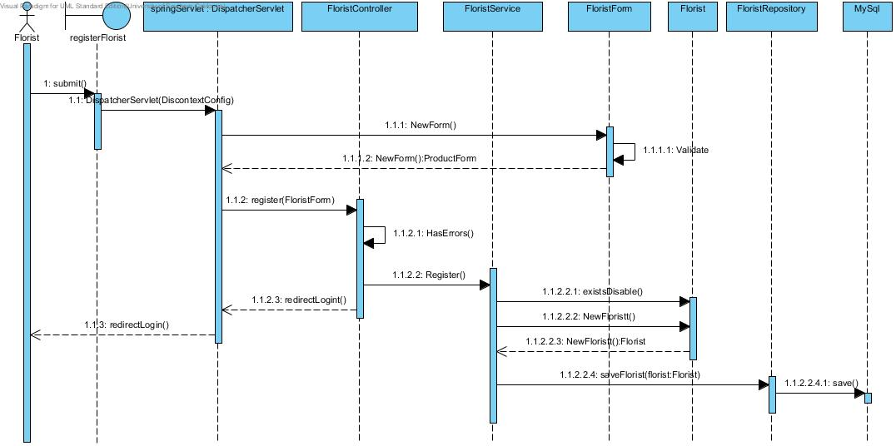

Figure 16: Florist Registration Sequence Diagram

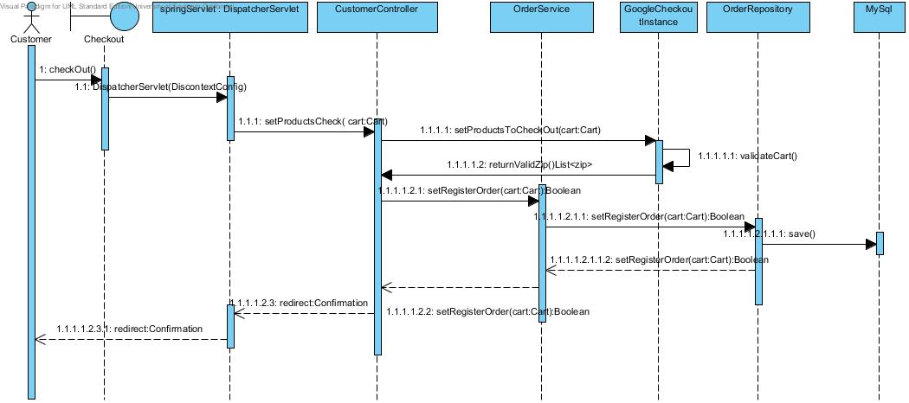

Figure 17: List Added Product Sequence Diagram

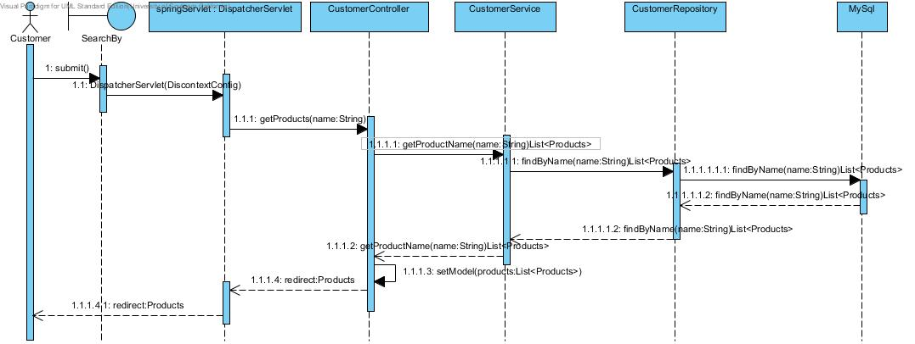
Figure 18: Search by name Sequence Diagram
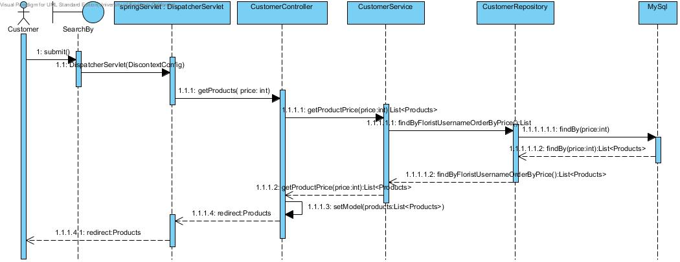

Figure 19: Search by price Sequence Diagram

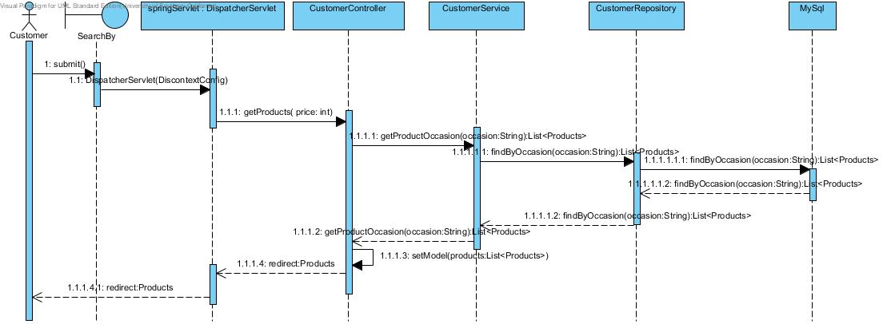

Figure 20: Search by Occasion Sequence Diagram

Figure 21: Payment Sequence Diagram

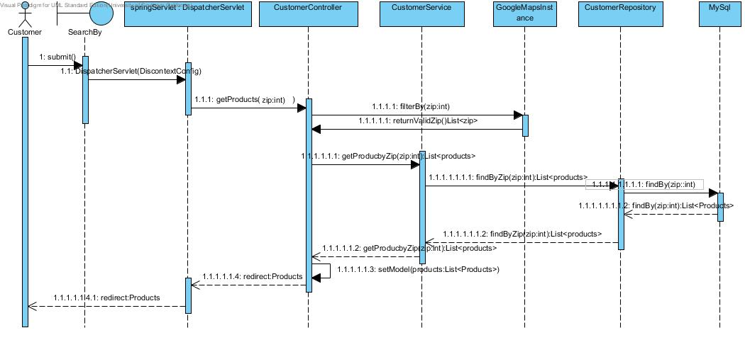Figure 22: Search by Location Sequence Diagram

Design Rationale
Our System is based on J2EE Project. It has three layers.
Presentation Layer (View): includes all the boundaries (pages) and view form classes.

Business Logic Layer (Control): includes all the controllers and various logic algorithms procedures. Validate user’s input and mapping user’s input to different operations.

Data Management Layer (Model): includes all the entities. Every Entity corresponds to one table in Database.

Frame - Work Layer: this layer is in charge of all the main objects creation, injection and database mapping objects and connections between the whole system layers.

Architectural Styles, Patterns and Frameworks
Table 12: Architectural Styles, Patterns, and Frameworks
Name | Description | Benefits, Costs, and Limitations
Brower-Server  Framework | Our project is a web-project. Client does not need to install any software, just need to have a browser on computer and connect to internet | Benefits:  (1)Redeploy project is very easy.  (2)Support multiple platforms.  Limits:  (1) Some features cannot be built because of the band width.
Google Wallet | Google wallet checkout provides a defined API that handles all payment processes in a secure manner | Benefits:  1)provides Secure, testable and available payment module for the system  2)Allows multiple payment methods  Limits:  1)Users need to create a account with Google  Cost: 1.9% per transaction
JPA | JPA enforces object oriented programming style. Allowing communication between objects and databases by replacing direct persistence communication between object-persistence entities | Benefits:  1) Implementation of database management objects becomes easier and less coupled  Limits:  1) JPA only deal with objects, if the system needs to retrieve simple data from a table, the entire object must be constructed and passed  Cost: Free
MVC | Object oriented design pattern. This pattern allows separating the logic, with the system view. Injecting all object oriented pattern benefits for a scalable project | Benefits:  1)Allows system scalability  2)Enhance developers system domain knowledge  Limits:  No known for FlowerSeeker  Cost: Free
SpringFramework | Framework that helps to build robust enterprise java applications, it provides different components for specific task such as database management. Free of charge and lightweight. | Benefits: Allows to decouple object on the system and provides several useful framework for database and view layers  Cost: Free of charge, but needs high learning curve from developers

